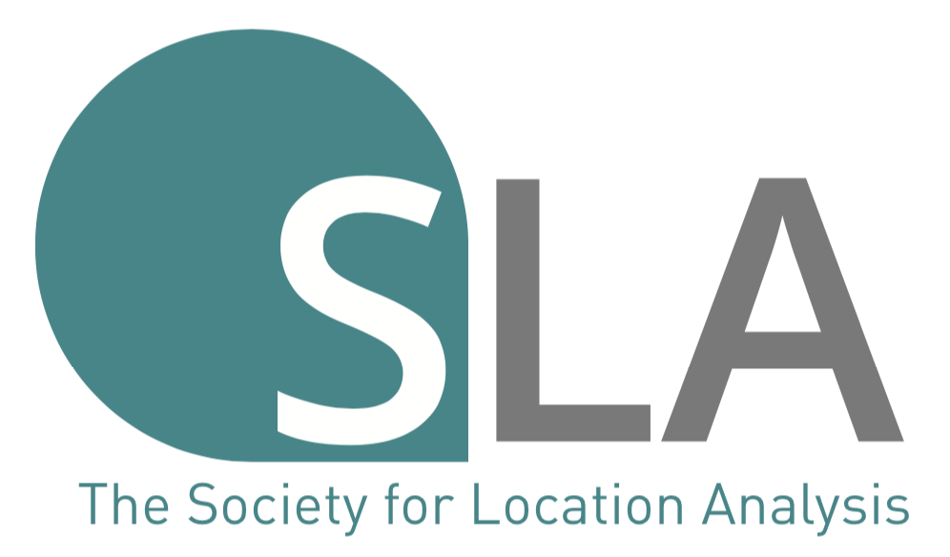
The Society for Location Analysis
Student Awards 2023

By submitting an entry to this competition, you confirm that you meet the following terms and conditions of entry. You are:
- Enrolled as an undergraduate (BA/BSc) or Masters (MA/MSc/MRes) student in the 2022/23 academic year
- Completing studies at a UK university / institute of Higher Education
- Completing a dissertation or final year extended project in the broad field of location analysis
Please complete all fields below to enter the 2023 SLA Student Award competition. All text boxes on this form are expandable.
Full name  (student): |  | Email address*  (student):
Full name (supervisor): |  | Email Address (supervisor):
Programme of study: |  | University:
Twitter handle**  (optional): |  | Entry Category†: | Undergraduate  Masters

* Please make sure you will have access to your email account later in the year should we need to contact you as a winner. Many university email addresses expire shortly after graduation so you may wish to provide a personal email address.
** The society will tweet news of the winners once selected by the judges. If successful and you are happy to be tagged in such promotional tweets, please include your Twitter handle if you are an active Twitter user (optional).
† Note that Undergraduate and Masters submissions will be considered in separate categories.
Firstly, please provide the full title of your dissertation/project below:

Secondly, please provide a brief synopsis of your dissertation/project below. This should be in the form of an abstract and should discuss general aims/direction and research rationale (maximum of 300 words).

Thirdly, please provide a short overview of the main findings of your research that may be of interest to SLA members; these may be listed in bullet point format if preferred (maximum of 300 words).

Finally, if there is anything else you would like to tell us about your work please include it here (optional). Note that you can include up to two graphics (e.g. maps, diagrams, graphical analyses etc) or simply additional information not covered by the previous three sections (maximum of 200 words). This section is optional.

Please submit the completed application form to: Ruth Holdroyd, SLA Secretary, at info@thesla.org by the deadline date. Informal enquiries can be made to Dr Luke Burns at L.P.Burns@leeds.ac.uk.

The deadline for entries is Friday 22nd September 2023, 5pm. Submissions after this time will not be accepted unless the deadline is extended and this will be widely publicised. Winners will be selected shortly after the deadline and contacted by email. One winner and one runner-up will be selected from both the Undergraduate and Masters categories.

Winners will be invited to attend an upcoming SLA event to meet members, network and collect their certificate and cash prize (winner: £200, runner-up: £100 in each category). Winners may be asked to present their work in a short 5-minute presentation. Any reasonable travel expenses (from within the UK only) will be covered by the society should this event take place in-person. Good luck!

Thank you for entering the Society for Location Analysis’ Student Awards 2023!

